CTEC601 2024 S2

Assignment 2 – A Synthetic Reality

# The Stardrop Saloon

# Team Members

|  |  |  |  |
| --- | --- | --- | --- |
| Name | Contribution description | Contribution weight | Signature |
| Ishanika Singh | e.g., Modelling, Sound, Texture | 33.3% |  |
| Abby | e.g., Modelling, Texture, Scripting | 33.3% |  |
| Liliana | e.g. Interaction, Lighting, Sound | 33.3% |  |

# Description

Roughly describe the project:

* Why did you decide for the location/scene/etc.?

*Our group chose to recreate The Stardrop Saloon from Stardew Valley because it’s a central iconic location in the game where many characters come together. The saloon represents a warm, communal space where the town’s residents relax and socialise, especially on Fridays, when everyone gets together. We felt that it captured the cozy, inviting atmosphere that we all love about the game. Recreating this space allowed us to bring that sense of camaraderie and nostalgia into our own project, which would provide a fun challenge to build and reimagine the virtual environment in 3D. We also decided to personalise it more by making it Junimo (an in-game character) themed as we love the character!*

* What core assets did you need for this project?

*The core assets we needed for this project included the jukebox, bar, outside environment and detailed objects like tables, chairs, beer mugs, bottles etc. We curated a list of model assets we need in order to complete the basic environment for the saloon. In addition, we needed texture assets for surfaces such as the wood, wallpaper, fabric to accurately depicts the cosy, rustic vibe of the saloon. Audio was another key asset, require us to capture both environmental sounds and the games popular background music that plays in the saloon. These assets were essential in making the scene feel authentic and immersive.*

* How did you record/create/process those core assets?

*To create and process these assets, we used Blender to model the saloons furniture, paying close attention to the details in the original game. For textures, we referenced the pixelated art style of Stardew Valley and enhanced it to fit within the 3D space, ensuring the textures matched the games story but were also cohesive to the 3D environment ensuring the textures matched the games cozy, hand-drawn aesthetic. We recorded in-game sounds directly from the game to capture the ambience and music of the saloon, using audio software to clean up and loop the sounds for continuous play in Unity.*

* Did you break down the project into steps/blocks? If so, which?

*We organised the project into two main phases. The first phase focused on modelling and interaction, where we built the structure of the saloon and its core elements. This allowed us to get the basic functionality and space laid out before moving onto the finetuning. The second phase was dedicated to texture application and lighting, where we enhanced the visual quality of the models and added mood lighting to replicate the warn, inviting glow of the saloon. We decided on an evening lighting environment as the villagers enter the Saloon from 7pm onwards in-game. This breakdown of steps helped us stay focused and methodical in achieving a polished and immersive result.*

# Sketches/Screenshots

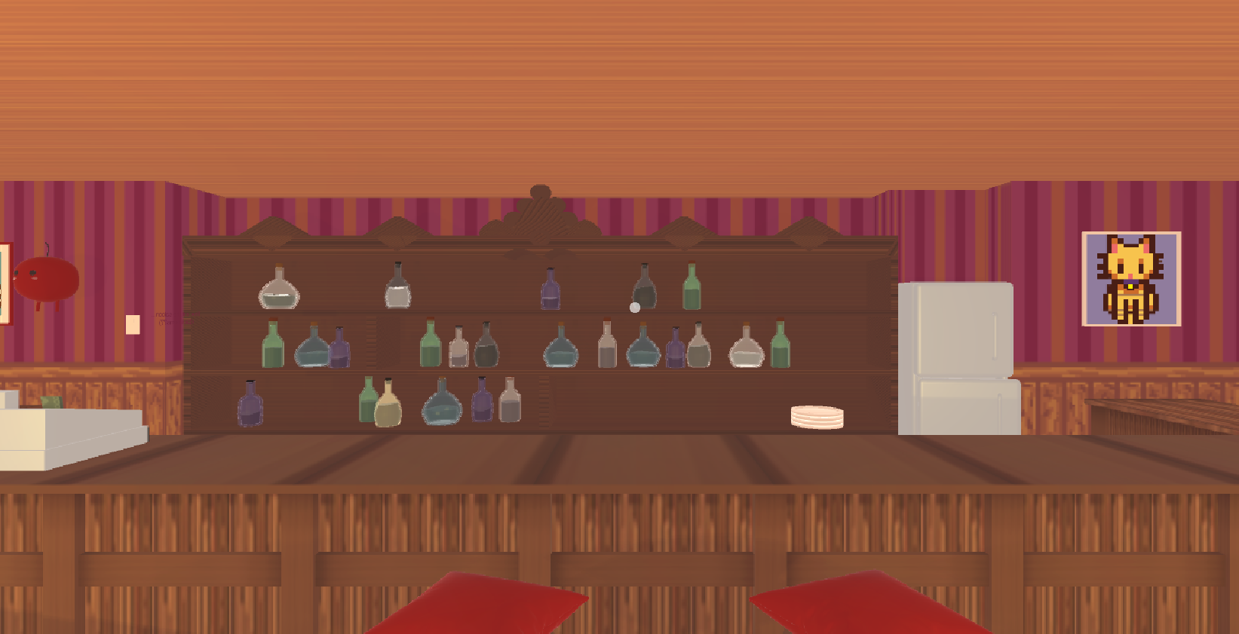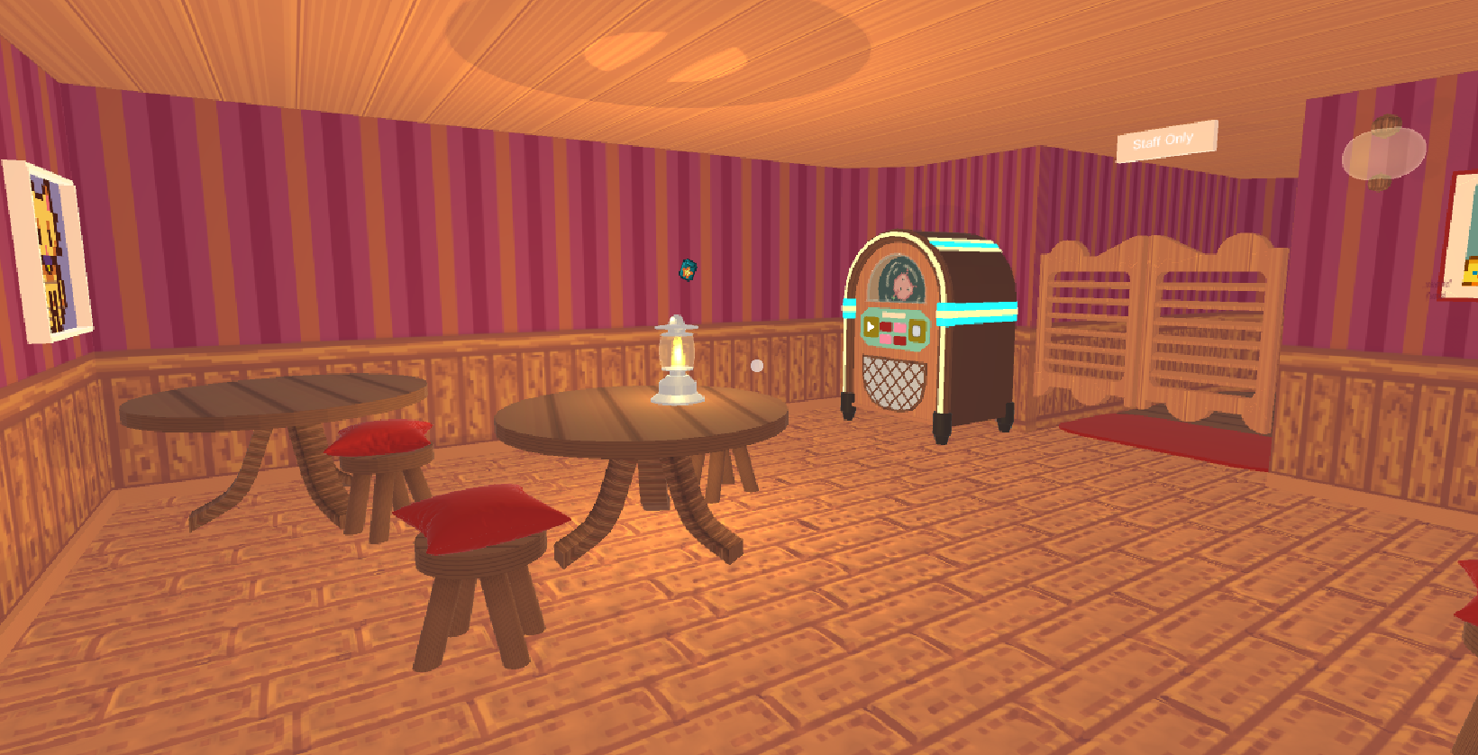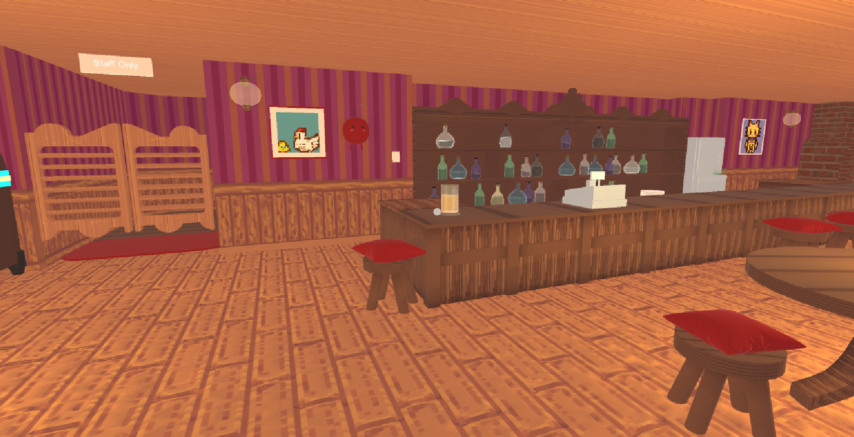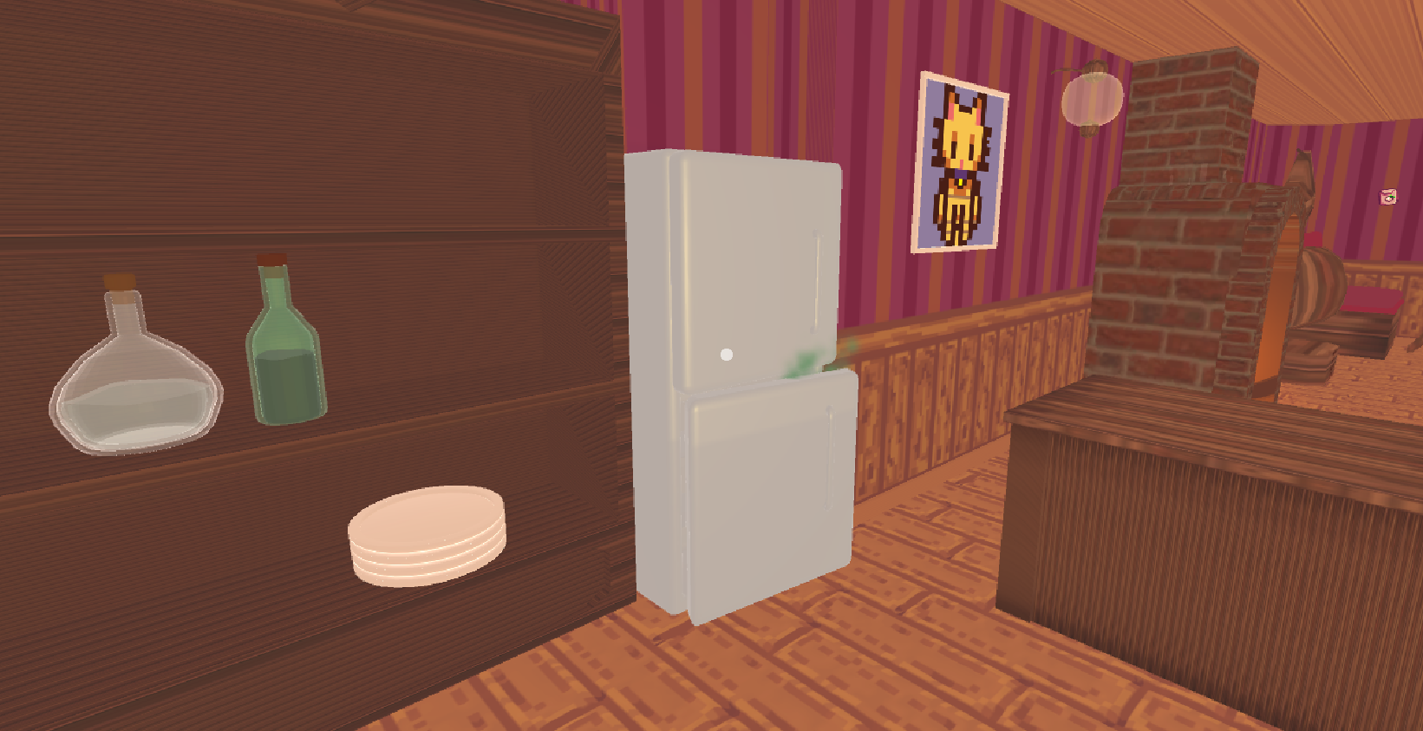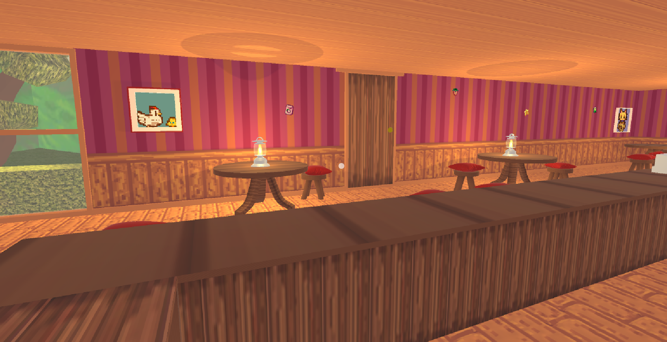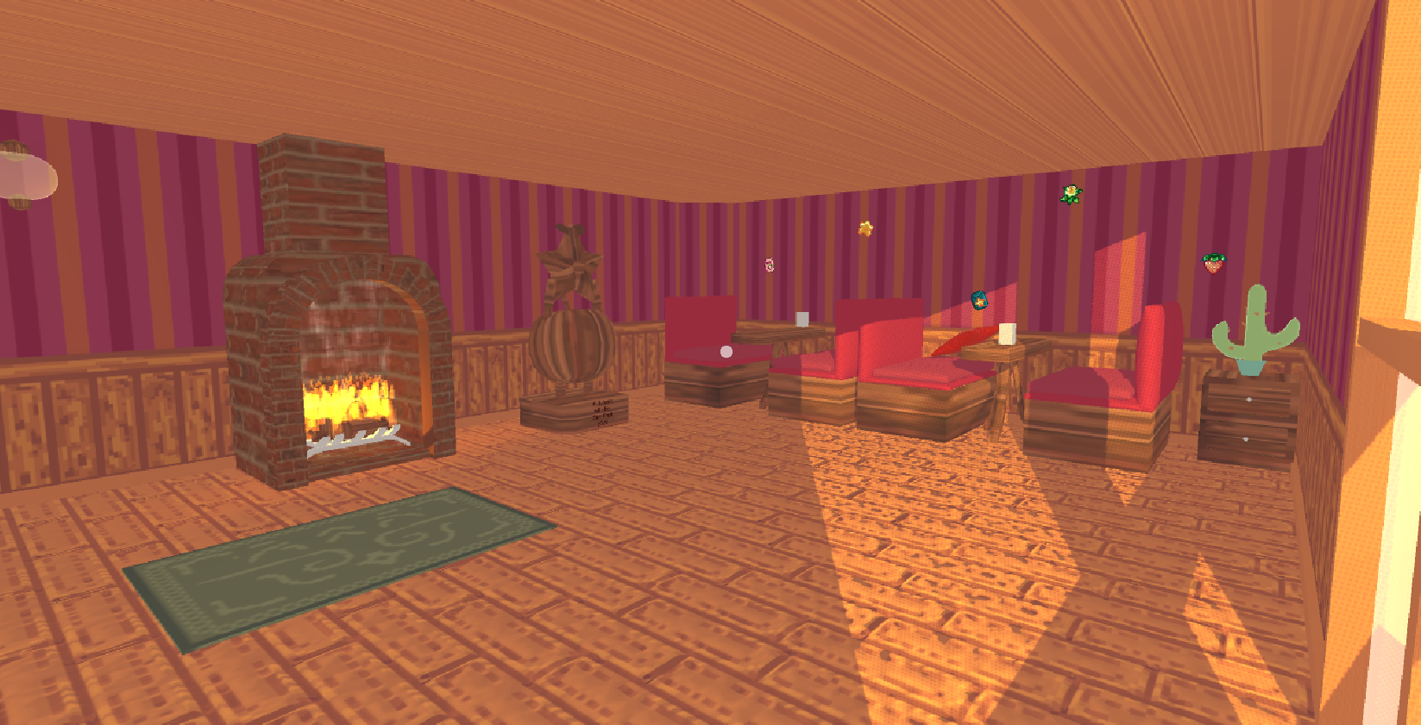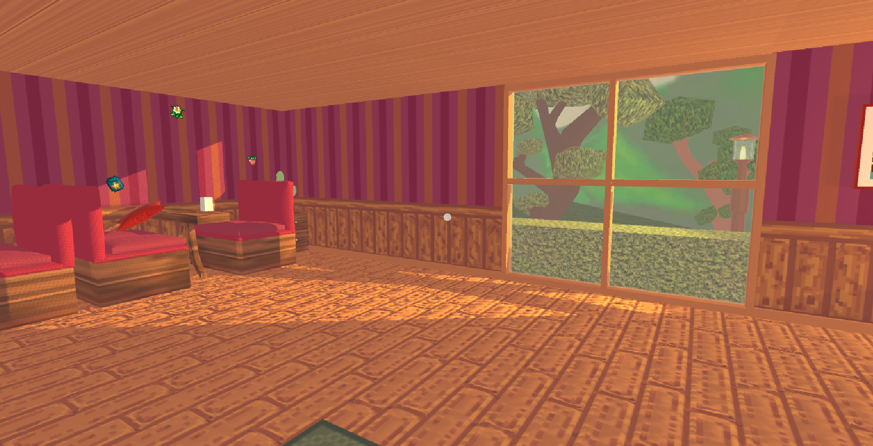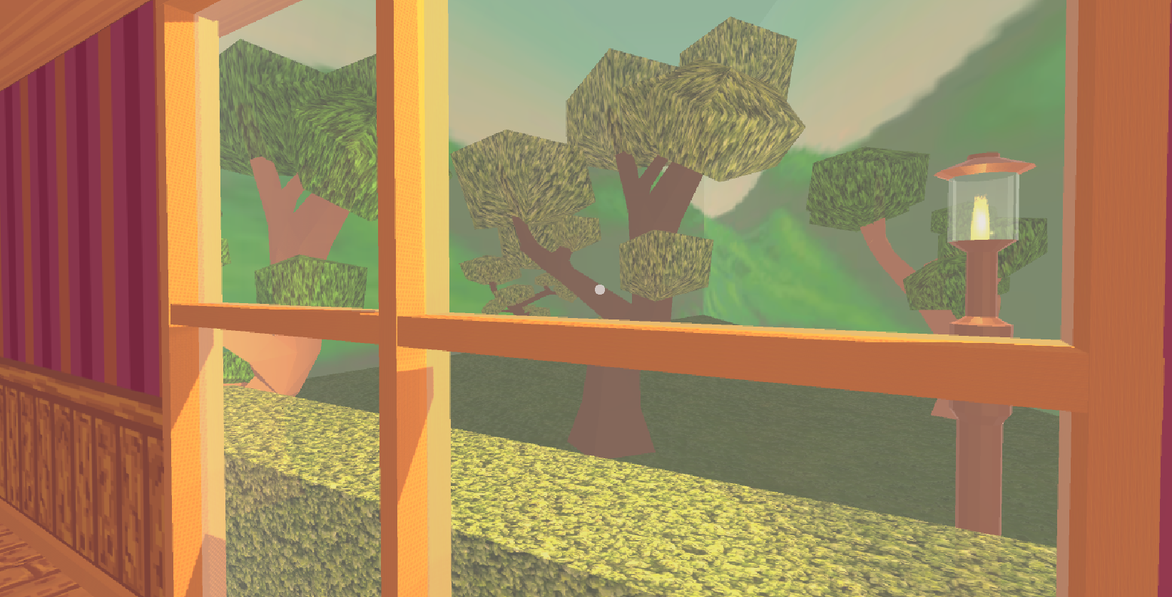

# Changelog/Diary

## 9/09/2024

* Assessment introduced in class
* Find group members
* Brainstorm ideas and locations

## 16/09/2024

* Planned and assigned models to work on.
* Lili was assigned working on the interactions and functionality while Abby and Ishanika distributed the models.
* We used the table below to organise models and structure. Since Liliana was working on interactions, lighting and functionality, her focus was less on models. Both Abby and Ishanika worked on the models for the saloon as well as texture, materials, and scripting. The document we created for organising also contained images of the saloon in game as well as different perspectives and close ups.

## 23/09/2024

* Worked on completing Jukebox, Vinyl and Movements in Unity.

## 30/09/2024

* Worked on just the texturing for the walls (not as many models) in order to get the blueprint of the saloon.

## 07/10/2024

* Worked on modelling small furnishings/decors such as bottles, cushions and organising the basic structure of the saloon.
* Worked on getting the interaction for the Jukebox to work

## 14/10/2024

* Wrapped up all the models so that we could focus on lighting and environment with a few fixes on interactivity.
* Added in all height and normal maps to materials.
* Finished scripting for the Jukebox music and finalised interactivity.
* Implemented sounds into the scene (jukebox and user sounds).

## 22/10/2024

* Finalised environment and environment textures.
* Focused on refining our work and producing something higher quality making sure all of the functions work as intended.